Rockland St Mary with Hellington Parish Council

Defibrillator Policy

Document Control
Adopted date | July 2018 | Minute reference
Last reviewed | May 2026 | Minute reference
Next review date | May 2027

- Weekly Check the colour of The Rescue Ready® indicator if the colour is:
  - Green: No action needed, the AED is ready for rescue
  - Red: Refer to trouble shooting of indicators, page 5-2 of user guide.

- 6 monthly carry out the following checks:
  - Check that the battery has adequate charge to perform a rescue:
    - If the battery indicator is red, replace the battery
  - Check that the voice prompts work and the display is readable:
    - Listen for the voice prompts
    - Additionally, check the display shows text prompts that correspond to the audio.
    - Close the lid. The voice prompts should stop.
    - Verify the Rescue Ready® indicator returns to green. If no prompts are heard or they continue after the lid is closed, the display is not readable, or the Rescue Ready® indicator remains red, there may be an issue with the AED. Contact your local agent or supplier.
  - Check that the defibrillation pads are ready for use and that the service beep sounds:
    - Disconnect the pads connector and remove the pads package.
    - Confirm that the Rescue Ready® indicator turns red and the AED beeps at a regular interval. If no sound is heard Contact your local agent or supplier.
    - Check the expiration date of the pads; if expired, replace the package.
    - Check the pads packaging is not ripped or punctured, replace the package as needed.
    - Open the lid and confirm that the defibrillation pads indicator is lit.
    - Reconnect the pads connector, put the pads back in the pad’s holder, close the lid.
    - Make sure the expiration date is visible through the window of the lid.
    - Make sure that the Rescue Ready® is green. If the indicator remains red, Contact your local agent or supplier.
  - Check that the LEDs work:
    - Confirm that the device briefly illuminates all the indicator LEDs:
      - 0%, 25%, 50%, 75%, 100% battery LEDs
      - Pads status LED
      - Service required LED
      - Shock button LED
      - Left function button LED
      - Right function button LED
  - Check the buttons work:
    - Within 15 seconds of opening the lid, press the soft buttons and shock button in turn. The buttons should illuminate. If one does not respond, Contact your local agent or supplier.
  - Check the AED case for signs of stress:
    - If you find cracks or other signs of stress Contact your local agent or supplier.

- Cleaning and care
Use a cloth dampened with an approved cleaning solution to wipe the case. Do not spray or pour the cleaning solution on the case or submerge the AED. Dry the case with a clean cloth.

Approved cleaning solutions: to clean the case of the AED, soapy water, denatured ethanol, or 91% isopropyl alcohol.

The AED and its accessories cannot be sterilised.

- Information
Cabinet access code: C159X
AED Serial no D00000006702 – Installation date 14/12/15

- Spares and Advice
Cardiac Science
Unit 2 Rugby Park
Battersea Road
Heaton Mersey
Stockport
SK4 3EB

Pads expire – 1st July 2026. To order by June 2026. (Cost £40+VAT each, as of November 2022)

Equipment Information

Model: Powerheart G5 Serial numbers:
D00000006702: Installation Date: 14/12/2015
D00000006727: Installation Date: 21/12/2015
Council Asset Numbers: Shop 0037
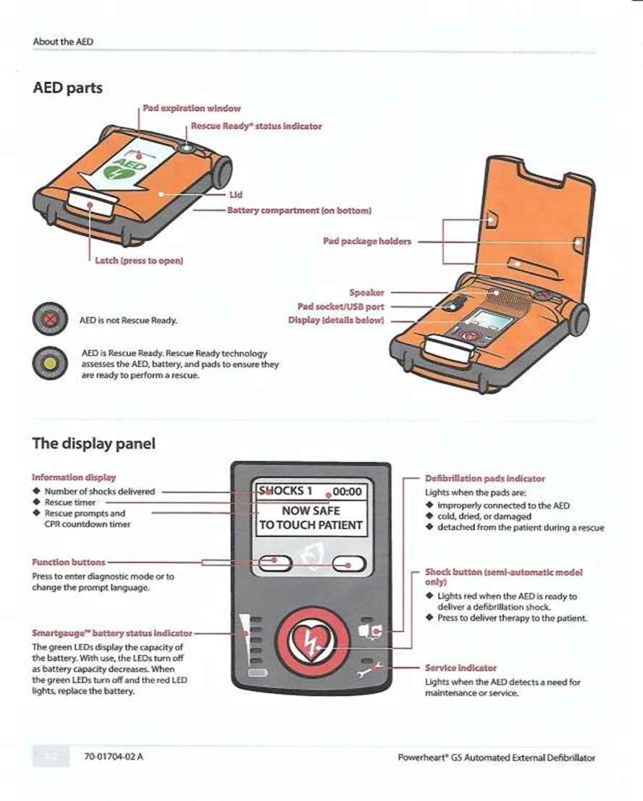
New Inn 0035

6-month checklist

Check that the battery has adequate charge to perform a rescue: | If the battery indicator is red, replace the battery
Check that the voice prompts work and the display is readable | Listen for the voice prompts
 | Additionally, check the display shows text prompts that correspond to the audio.
 | Close the lid. The voice prompts should stop.
 | Verify the Rescue Ready® indicator returns to green. If no prompts are heard or they continue after the lid is closed, the display is not readable, or the Rescue Ready® indicator remains red, there may be an issue with the AED. Contact your local agent or supplier
Check that the defibrillation pads are ready for use and that the service beep sounds | Disconnect the pads connector and remove the pads package
 | Confirm that the Rescue Ready® indicator turns red and the AED beeps at a regular interval. If no sound is heard Contact your local agent or supplier.
 | Check the expiration date of the pads; if expired, replace the package
 | Check the pads packaging is not ripped or punctured, replace the package as needed.
 | Open the lid and confirm that the defibrillation pads indicator is lit.
 | Reconnect the pads connector, put the pads back in the pad’s holder, close the lid.
 | Make sure the expiration date is visible through the window of the lid.
 | Make sure that the Rescue Ready® is green. If the indicator remains red, Contact your local agent or supplier.
Check that the LEDs work
Check that the LEDs work | Confirm that the device briefly illuminates all the indicator LEDs: | 0%, 25%, 50%, 75%, 100% battery LEDs
Check that the LEDs work |  | Pads status LED
Check that the LEDs work |  | Service required LED
Check that the LEDs work |  | Shock button LED
Check that the LEDs work |  | Left function button LED
Check that the LEDs work |  | Right function button LED
Check the buttons work | Within 15 seconds of opening the lid, press the soft buttons and shock button in turn. The buttons should illuminate. If one does not respond, Contact your local agent or supplier.
Check the AED case for signs of stress | If you find cracks or other signs of stress Contact your local agent or supplier

