Rockland St Mary with Hellington Parish Council
Biodiversity Policy

DOCUMENT CONTROL
Adopted date | March 2024 | Minute reference | 24.46.01
Last reviewed | July 2024 | Minute reference | 24.103.01
Next review date | July 2026 | Minute reference

Introduction
In accordance with the Duty imposed on parish councils by Section 40 of the Natural Environment and Rural Communities Act (NERC) 2006, people responsible for activities, events and developments within the Parish of Rockland St Mary with Hellington are required to consider the effects on wildlife and biodiversity to preserve and, where possible, enhance the wildlife and biodiversity of the local area. This duty also means that town and parish councils can spend funds in conserving biodiversity. Rockland St Mary and Hellington is situated in the Yare valley and enjoys the benefits of a village community within a rural setting. Wildlife and Biodiversity form an integral part of our community and must be preserved and enhanced.

This Parish Council has a proactive and engaged community which champions nature conservation, biodiversity and habitat protection. The Parish Council already introduced a Wildlife Policy in 2021 which sought to recognise and provide information on meeting the biodiversity challenge at the village level. The aim of this new Biodiversity Policy document is to update and incorporate the Wildlife Policy and to fulfil obligations in Section 40 of the Natural Environment and Rural Communities Act 2006, updated by Section 102 of the Environment Act 2021 for Parish Councils to:

- consider what more the Parish Council can do to conserve and enhance biodiversity.
- agree policies and specific objectives based on these considerations.
- act to deliver actions to achieve policy goals and objectives.

DEFINITION
According to Defra (Biodiversity 2020), biodiversity is the variety of all life on Earth. It includes all species of animals and plants – everything that is alive on our planet.

Biodiversity is important for its own sake and has its own intrinsic value. A number of studies have shown this value also goes further. Biodiversity is the building block of our ‘ecosystems’ that in turn provide us with a wide range of goods and services that support our economic and social wellbeing. These include essentials such as food, fresh water and clean air, but also less obvious services such as protection from natural disasters, regulation of our climate, and purification of our water or pollination of our crops. Biodiversity also provides important cultural services, enriching our lives providing spaces to improve mental health and enjoyment of nature.

AIMS AND OBJECTIVES
The Parish Council aim to improve the biodiversity of the area in the following ways:

- consider the sustainability, environmental impact and biodiversity when providing responses to planning applications and making decisions and will develop and implement policies and strategies as required.
- manage its land using environmentally friendly practices that will encourage biodiversity.
- promote the adoption of low impact / nature positive practices for residents, businesses and groups operating in the Parish.
- encourage and support other organisations within the parish, and with surrounding villages as appropriate, to manage their areas of responsibility with biodiversity in mind.
- support residents and local organisation activities to champion biodiversity (through signposting resources and tools as well as relevant best practice).

The object of this policy is to work towards protecting, conserving and enhancing the biodiversity of the Council’s area.
Local wildlife area

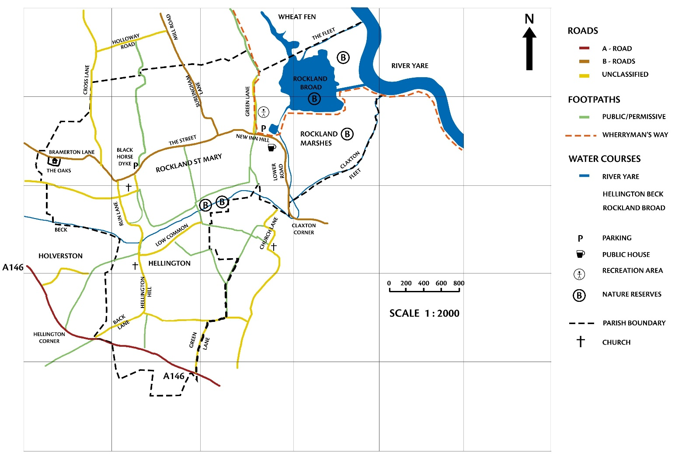

ACTIONS

Planning applications
The Parish Council will:

- when commenting on planning applications, support site and building design that benefits biodiversity through the conservation and protection of existing habitats and the provision of new habitats.
- support protection of sensitive and valued natural habitats and assets from development and will consider whether any proposed development would mean the loss of important habitats for wildlife in respect of all applications. Habitats classed as important include those that are included in SN14 Habitats of Principal Importance under the NERC Act, and/or priority habitats in the Broads Drainage Board Biodiversity Action Plan (2018).
- consider what each proposed development might deliver in terms of biodiversity net gain and mitigation of habitat loss.

Land management
The Parish Council will:

- consider carrying out a biodiversity audit and/or community-led data collection of its landholdings and/or private gardens and land (i.e. through participation in the RSPB Annual Garden Bird Count).
- consider the conservation and promotion of local biodiversity with regard to the management of its open spaces. This will include adopting beneficial practices with regard to new planting plans, the timings for cutting and removal of vegetation, the application of harmful chemicals, including herbicides and pesticides, and timing of major maintenance work, paying attention to the Government’s regulations for plant protection products.
- take special care in the specification of grounds maintenance/caretaker contracts to ensure that the work, whilst reaching acceptable standards, does not harm the natural environment.
- Source sustainable, recycled or reused materials, as relevant, and seek to source UK produced and FSC certified plants and wood, as well as disease free plants when procuring supplies for the Council’s use.

Local community
The Parish Council will:

- raise public awareness of biodiversity issues, including through its website, via social media channels, stakeholder and community engagement.
- engage with local businesses and residents regarding biodiversity in the community and how members of the community can assist and make a difference.
- where feasible, involve the community in biodiversity projects on its land including for example tree planting, wild patches, birdbox making, garden audits of wildlife and plants.

What can residents do around the home?

- Put up nest boxes, bug boxes, bat boxes and bird feeders.
- Create holes in fences for hedgehogs and amphibians to pass.
- Plant shrubs for birds.
- Plant nectar rich flowers for butterflies and bees.
- Create a wildlife pond or leave damp areas for mosses and fungi.
- Leave corners of the garden and areas of grassland for wildflowers to establish and flourish.
- Avoid or stop use of harmful chemicals such as pesticides.

A walk or ride in our countryside?

Residents and visitors to the countryside around Rockland St Mary and Hellington enjoy the many public footpaths which are maintained by Norfolk County Council and local farmers. We are fortunate to have several excellent biodiverse wildlife habitats and environments on our doorstep: Rockland Broad and marshes are valuable resources for overwintering and nesting birds, e.g. bittern, marsh harrier, wigeon, lapwing and the rare cuckoo. Hellington Low Common County Wildlife site is nationally important for common spotted orchids and common twayblades, whilst Hellington and Rockland St Mary Community Reserve is an ideal place to have a picnic, explore the beck and enjoy the mix of grassland and alder carr environments.

Please follow the Countryside Code.

Wildlife issues

It is recognised that occasionally some aspects of wildlife and biodiversity can be detrimental to our health and safety and must be treated with caution. For example, rat infestation, wasp nests, harmful animals in roof spaces, bedbugs etc. within the domestic environment. It should be remembered that most bee and wasp nests are not harmful if left undisturbed and that these insects play a crucial role in crop and wildlife pollination.
Advice on treatment is available at: Pest control in South Norfolk – Broadland and South Norfolk (southnorfolkandbroadland.gov.uk)

Stakeholder Engagement

It may review any local nature recovery strategies, species conservation strategies, or protected site strategies in respect of local Sites of Special Scientific Interest (SSSIs) and consider how it may contribute in implementing the strategies’ recommendations.

ACTION PLAN

SITE / OBJECTIVE | ACTION | OUTCOME | TARGET  (Years) | REPORTING / PUBLICITY
Whole council area - increase  community awareness of biodiversity | Ask residents/stakeholders/groups and volunteers in the community for views on what they would like to be done to conserve biodiversity within the parish. Encourage local farmers to contribute.  Raise awareness of the importance of gardens as habitats for wildlife, with possible actions highlighted on the parish website.  Create a page on the parish council website for  photographs / information / links.  Discourage floodlighting.  Encourage hedgehog/small animal highways with  permeable boundaries | Gain local support and engagement for action.  Engagement/ownership of biodiversity.  Extending habitats.  Protect nocturnal animals. | Ongoing | PC/ village groups on social media, website, Eleven Says (all villages approach), community and stakeholder engagement.
Protect and support  biodiversity | Encourage suitable planting to support biodiversity with focus on the establishment of a new community orchard at the Green Lane Playing Field Site. | Diversify habitats to meet the needs of a variety of  wildlife species and raise awareness of natural environment | Ongoing | PC/village groups on social media, website, flyers, tree festival/fete
Community Orchard,  Green Lane Playing Field, Black Horse Dyke. | Additional planting and continued stewardship and engagement with residents.  Install, maintain and renew bird and bat boxes as required.  Adopt appropriate methods to support wildlife and diversity whilst maintaining the sites in a way which enables visitors to experience quiet and calm remembrance at each of the sites, respectively.  Leave leaf litter and dead vegetation in discreet areas wherever possible as a habitat for invertebrates.  Sympathetically maintain hedging.  Only use environment friendly pesticides/herbicides where absolutely necessary and only in ideal weather conditions. | Increased diversity of habitats and food sources  Increased cover for invertebrates, reptiles, amphibians and small mammals.  Encouraging insects particularly butterflies and bees.  Sustain and enhance  natural habitats, including stewardship for native and wild flowers and plants. | Ongoing | Event attendance, social media and website updates
Common / other open spaces – public paths, trails, seating areas. | Encourage residents to remove litter and pick up after their dogs.  Work with the County Council on verge management, favouring biodiversity but noting which areas may need cutting for highway safety.  Encourage residents to adopt areas to look after, making it clear what is expected e.g. peat free compost and no chemicals. | Sustain, protect and enhance  natural habitats. | Ongoing
Support  Community  Projects | Support hedge/tree planting in any appropriate areas.  Work in partnership with the school, local groups and stakeholders to develop young people’s and residents’ awareness of the environment around them.  Consider events and offer volunteering opportunities to support biodiversity, working with local organisations and volunteers. | Extending habitats.  Promote biodiversity. | Ongoing

