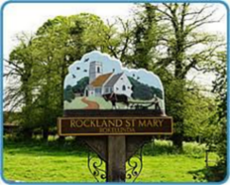
Rockland St Mary with Hellington Parish Council
AGENDA

Date: Wednesday 25th February 2026
Time: 7.30pm
Place: Parish Room, Rockland St Mary
AGENDA
1. Welcome.

2. Approval of the Minutes of 22 October 2025.
3. Matters arising: None.

4. Reports and updates from members:
4.1 RWA.
4.2 Poor's Trust.
4.3 RSPB.
4.4 Wheatfen.
4.5 Broads Authority.
4.6 South Yare Wildlife Group.

5. Bird Hide – Progress report.

6. AOB and any matters for inclusion at the next meeting.

7. Confirm next meeting date.

