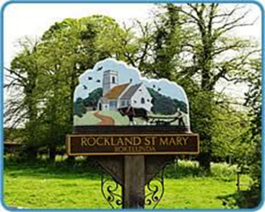
Rockland St Mary with Hellington Parish Council
Charlotte Rust, Parish Clerk
07960 887791
parishclerk@rocklandstmarywithhellington-pc.gov.uk
Minutes of Rockland Broad Management Committee held on Wednesday 13th March 2024 at 7.30pm in
The Parish Room, Rockland St Mary

Present: Councillor Joanne Norris
Councillor Janet Rogers
Peter Armitage (SYWG)
Tim Strudwick (RSPB)
Charlotte Rust (Parish Council Clerk)
Apologies: Will Fitch (Wheatfen)
Seb Shelton (Poor’s Trust)
Wildfowlers
Broads Authority

1. Welcome.
Councillor J Rogers welcomed all in attendance to the meeting.
2. Minutes of last meeting.
Minutes were approved, subject to the amendments as per item 4.1,
3. Matters arising:
3.1 Bird Hide.
The pre-planning application has been submitted and there was no charge involved.
The Broads Authority visited the site on 13th March 2024. There are possible plans to put dredgings near the Bird Hide site within the next 2 years.
A draft lease has been issued which is to be reviewed and amended as required. A copy has been sent to Sarah at RSPB and will be submitted for a legal review.
The Environment Agency has given the working group advice on the replacement of the bird hide and what permits to apply for etc.
3.2 Broads Authority update on dangerous moorings.
The Broads Authority have this matter in hand.
4. Reports and updates from members:
4.1 RWA.
The Parish Clerk read the RWA’s report:
We looked through the October meeting minutes and have a query about some of the text in item No.4.
RWA was formed with the help of the Parish Council and English Nature (Now Natural England), to help regulate the shooting on Rockland Broad due to the broad previously being a ‘free for all’ for wildfowlers. Up to 40 wildfowling boats were often on the broad at any one time before RWA was formed so it did indeed need a group like ourselves to come in to keep the shooting regulated. Maybe if the text could be adjusted to say… The reason the committee was formed originally was to ensure the safety of the public from ‘unregulated’ shooting on the broad.
It's just a thought really. We just feel that the current text gives the impression that our club is being singled out as a safety concern, when in fact our presence enhances broad safety for all users.
This coming Saturday 16th March a few of our members and committee are planning to venture onto the Broad to collect any litter from around the reedbeds. I will let you know the outcome with photos.
4.2 Poor's Trust.
None.
4.3 RSPB.
For the first time in 50 years, the RSPB has acquired 6 hectares of land.
The rainfall/flooding that has been seen over the last 12 months will be deemed ‘average’ in 30 years’ time, however there is more fresh water as a result.
Ducks – numbers are good after they had dwindled in the past.
Shorted owls – Record number of 27 has been recorded.
4.4 Wheatfen.
None.
4.5 Broads Authority.
None.
4.6 South Yare Wildlife Group.
The group has held talks on plants and plant life. The plant population is Rockland St Mary has gone up since 2021 with an increase on the number of species.
Swan pairings on the dyke are lower.
A bat talk has been arranged at Claxton Village Hall on 21st March 2024.
Breakfast with the birds at Surlingham will be held on 12th May 2024.
5. AOB and any matters for inclusion at the next meeting.
Bird Hide
BA moorings
6. Confirm next meeting date.
The next meeting will be held on Wednesday 16th October 2024 at 7:30pm.

