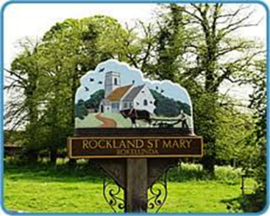
Rockland St Mary with Hellington Parish Council
Charlotte Rust, Parish Clerk
07960 887791
parishclerk@rocklandstmarywithhellington-pc.gov.uk

Date: Wednesday 18th October 2023
Time: 7.30pm
Place: Parish Room, Rockland St Mary
AGENDA
1. To discuss reverting the Broads Management Committee to a working Group.

2. Minutes of last meeting.
3. Matters arising:
3.1 Bird Hide
3.2 Broads Authority update on dangerous moorings
3.3 Broads Authority update re canoe access via slipway
3.4 Boats mooring to close to the slipway for trailers to manoeuvre boats in and out of the Staithe

4. Reports and updates from members:
4.1 RWA
4.2 Poor's Trust
4.3 RSPB
4.4 Wheatfen
4.5 Broads Authority
4.6 South Yare Wildlife Group
5. AOB and any matters for inclusion at the next meeting.

6. Confirm next meeting date.

