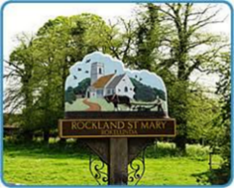
Rockland St Mary with Hellington Parish Council
AGENDA

Date: Wednesday 16th October 2024
Time: 7.30pm
Place: Parish Room, Rockland St Mary
AGENDA
1. Welcome.

2. Minutes of last meeting.
3. Matters arising:
3.1 Bird Hide.
3.2 Broads Authority update on dangerous moorings.

4. Reports and updates from members:
4.1 RWA.
4.2 Poor's Trust.
4.3 RSPB.
4.4 Wheatfen.
4.5 Broads Authority.
4.6 South Yare Wildlife Group.
5. AOB and any matters for inclusion at the next meeting.

6. Confirm next meeting date.

