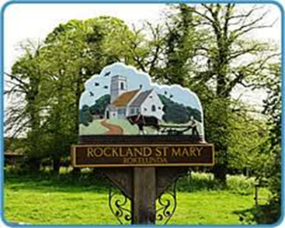
Rockland St Mary with Hellington Parish Council
Charlotte Rust, Parish Clerk
07960 887791
parishclerk@rocklandstmarywithhellington-pc.gov.uk

Date: Wednesday 24th May 2023
Time: 7.30pm
Place: Parish Room, Rockland St Mary
AGENDA
1. To discuss appointment of a Chair.

2. Minutes of last meeting.
3. Matters arising:
3.1 Bird Hide - an update from Tim Strudwick.
3.2 Update on damaged key heading and removal of stock fencing (TS).
3.3 Broads authority update on dangerous moorings belonging to Mr D Lodes (BA rep).
3.4 BA website update re canoe access via slipway.

4. Reports and updates from members:
4.1 RWA
4.2 Poor's Trust
4.3 RSPB
4.4 Wheatfen
4.5 Broads Authority
4.6 South Yare Wildlife Group
5. AOB and any matters for inclusion at the next meeting.

6. Confirm next meeting date.

