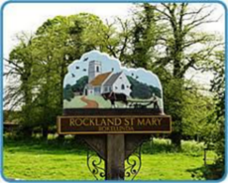
Rockland St Mary with Hellington Parish Council
AGENDA

Date: Wednesday 26th February 2025
Time: 7.30pm
Place: Parish Room, Rockland St Mary
AGENDA
1. Welcome.

2. Minutes of last meeting.
3. Matters arising:
3.1 Bird Hide.

4. Reports and updates from members:
4.1 RWA.
4.2 Poor's Trust.
4.3 RSPB.
4.4 Wheatfen.
4.5 Broads Authority.
4.6 South Yare Wildlife Group.

5. To consider disbanding the Rockland Broad Management Committee.
6. AOB and any matters for inclusion at the next meeting.

7. Confirm next meeting date.

