Rockland St Mary with Hellington Parish Council
Minutes of the Parish Council Meeting held on Wednesday 1st July 2026 at 7.30pm in The Parish Room, Rockland St Mary
(Subject to amendment until signed by the Chair at the next meeting)
Parish Councillors present Janet Rogers (Chair), Joanne Norris (Vice-Chair), Paul Francis, Jayme Forbes, Antony Wright, John Sayles
County Councillor None
South Norfolk District Councillor Vic Thomson – Left the meeting at 20:01pm
Members of the public (MOP) Two – Charlotte Rust; Parish Clerk and Steve Gildersleeve

26.81 Welcome from the Chair.
Chair Rogers opened the meeting at 19:35pm and welcomed all those in attendance.
26.82 To receive and approve apologies for absence.
Councillor Harkin sent her apologies.
26.83 To receive any declarations of interest from Members & consider requests for dispensation.
None.
26.84 To approve minutes of Parish meeting of 3rd June 2026.
Councillor Wright proposed to approve the June 2026 minutes subject to the following amendments:
26.71.08.01 – amend ring to bring.
26.70 – Blackhorse Dyke car park sign location confirmation – Councillors unanimously agreed to install one post with two signs back-to-back at the entrance on the left-hand side as you enter, using a jubilee clip.
Seconded by Councillor Forbes.
26.85 Matters arising from June’s meeting.
- FP3 - Norfolk County Council confirmed the Parish Council’s request for a pedestrian crossing does not meet the requirements.
- Car park sign for Blackhorse Dyke – please refer to Minute 26.84.
- Update on 23 The Street – the Clerk has chased the Highways Officer requesting an update, but no response has been received.
- Fencing at Green Lane – no further updates due to the extreme weather conditions.
- Woodchip at Community Orchard – this item is deferred until September’s meeting.
- Land transfer – South Norfolk District Council’s Community Asset team will come back as no instructions have been given as part of the Local Government Reform.
- School Lane bus stop sign – all repaired.
26.86 Reports from:
26.86.01 County Councillor, Councillor Mason-Billig.
None.
26.86.02 District Councillor, Councillor Thomson.
Councillor Thomson gave an overview of his report; a full version will be available on the website once the Clerk has received it:
- Heat warning – stay safe, following incidents using open water, fires and heatstroke.
- VCHAPS report is due imminently.
Councillor Sayles asked what the plans were for Data Banks across the County as he was concerned about the power usage. Councillor Thomson confirmed there are Data Banks already in place and the water to cool the system down is reused.
26.86.03 Clerk Report.
- Emailed the parishioner with a draft copy of the Memorandum of Understanding ready for defib installation. Please refer to Minute 26.86.05.01.
- Contacted Parochial Church Council regarding dog fouling. Revd Nick Garrard was on holiday until end of June, email sent 29th June. He will raise this at the next Parochial Church Council meeting.
- Submitted Rockland St Mary with Hellington and Rockland School’s Litter Pick information.
- SAM2 locations on mapping software – September 2026.
- BMX inspection template – thank you to Councillors Francis and Forbes for completing the weekly checks.
- Quotes for Green Lane valuation – none received at the time of the meeting.
- Internal Control Training – the Clerk is to book the Margaret Mack Room for 15th July at 7:30pm.
- Continued archiving and cataloguing Parsh Council documents.
- Forwarded on all relevant correspondence.
26.86.04 Councillor Francis – Footpaths.
FP5 between Low Common and Claxton the rape field is impassable currently. The Clerk is to contact the Landowner.
26.86.05 Councillor Sayles and Steven Gildersleeve (SG), Caretaker – Blackhorse Dyke Car Park and defibrillators.
Councillor Sayles mentioned the life ring should be on the fence. Councillors Francis and Wright will arrange this.
Steve Gildersleeve confirmed he will rake the gravel at Blackhorse Dyke during the school holidays and reassess whether further gravel is needed.
26.86.05.01 To approve the defibrillator Memorandum of Understanding with the addition: ‘The Parish Council agrees to cover the costs of installation’.
Councillor Francis proposed to approve the above addition to the Memorandum of Understanding, subject to the following amendments:
Add the defib exact location and that the Parish Council will cover the ongoing running costs under the Responsibilities section.
Seconded by Councillor Norris.
The Clerk is to contact the parishioner asking him to cut back the overhanging tress branches.
26.86.05.02 To approve the installation quotation from DCS Electrical Solutions of £405 +VAT.
Councillor Francis proposed to approve the quote from DCS Electrical Solutions of £405+VAT, which will be paid upon installation and invoice to the Parish Council. Seconded by Councillor Wright.
26.86.06 Councillor Forbes – SAM2.
Councillor Forbes has downloaded June’s data and will forward it on once he has extracted the information.
26.86.06.01 To approve additional SAM2 location on New Inn Hill by footpath 3 on the 30mph repeater sign.
Councillor Forbes proposed to approve the additional location on New Inn Hill, seconded by Councillor Sayles.
The Clerk will submit the undated Memorandum of Understanding to Norfolk County Council to formally approve and order a bracket and jubilee clips.
26.86.07 Councillor Harkin – Biodiversity.
Councillor Norris informed the Parish Council that the 5-mile network has arranged a picnic on Monday 6th July at 7pm at the Community Orchard.
26.86.08 Councillor Norris – Bird Hide.
The working group has received one quote so far and is waiting for a further two.
26.87 Adjournment for Public Participation (15 minutes allowed for).
None.
26.88 Internal Control Checks:
26.88.01 To receive and approve Internal Control Check Q4 2025-2026 – Councillor Norris to lead.
Councillor Norris proposed to approve the Internal Control Check Q4 2025-2026 as all was in order, seconded by Councillor Sayles.
26.89 To discuss and consider submitting a request asking for the permissive footpath near FP3 to become a Public Right of Way.
Councillors unanimously, by show of hands, rejected the request but will review it if the permissive path closes or the proposed Eel Catcher VCHAP site is approved.
26.90 To approve the completed Evidence Form regarding Green Lane’s status.
Councillor Forbes proposed to approve the Evidence Form and to submit it to Norfolk County Council, seconded by Councillor Norris.
26.91 To receive an update from Councillor Forbes regarding his Community Engagement training.
Councillor Forbes found the training insightful, and it provided a few ideas to increase the Parish Council’s presence:
- Pond dipping event at Blackhorse Dyke Pond
- Coordinating a Village Fete
- Drop-in sessions at the Post Office
- Club day at Blackhorse Dyke – village clubs attend to promote activities.
He will prepare further ideas/suggestions for September’s meeting.
26.92 Planning:
26.92.01 Applications: None at time of publication.
Noted.
26.93 Finance:
26.93.01 To receive a Bank Reconciliation and Statement of Account as of 1st July 2026.
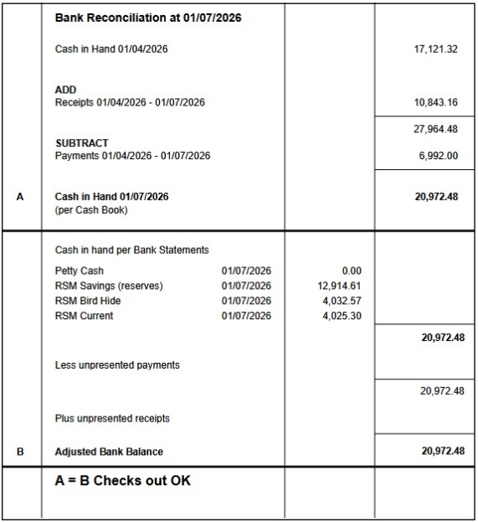

Councillor Wright proposed for the Chair and Responsible Finance Officer sign the Bank Reconciliation dated 1st July 2026, seconded by Councillor Sayles.
26.93.02 To consider and approve the increase to mileage rates, in accordance with HMRC rates and approve the back dated mileage payment for the Clerk.
Councillor Forbes proposed to increase the mileage rates, in accordance with HMRC rate and approve the Clerk’s back dated mileage payment of £2.64, seconded by Councillor Francis.
26.93.03 To note any receipts and approve payments as per July’s Payment Schedule.
FOR APPROVAL
 | DATE | EXPENDITURE | PAYMENT METHOD | TOTAL | VAT
Mr S Gildersleeve | 02.07.26 | June salary | BACS | £433.50 | £0.00
Clerk | 02.07.26 | July expenses and back dated mileage | BACS | £7.48 | £0.00
Clerk | 27.07.26 | July salary and WFH | BACS | £489.33 | £0.00
Clerk | 27.08.26 | August salary and WFH | BACS | £489.33 | £0.00
HMRC | 02.07.26 | Employer NI and Employee PAYE up to 5th August | BACS | £12.47 | £0.00
HMRC | 27.08.26 | Employer NI and Employee PAYE up to 5th September | BACS | £12.47 | £0.00
DSC electrical | 02.07.26 | Defib installation | BACS | £486.00 | £81.00
TO NOTE INCOME
RWA | 05.06.26 | Lease 26/27 | BACS | £1,300.00 | £0.00
Barclays | 08.06.26 | Interest Bird Hide | BACS | £11.46 | £0.00
Barclays | 08.06.26 | Interest Reserves | BACS | £31.70 | £0.00
Councillor Norris proposed to approve July’s Payment Schedule, seconded by Councillor Wright.
26.94 Correspondence:
26.94.01 To consider a parishioners request for new equipment at Green Lane Playing Field.
The Clerk will reply the parishioner explaining the Parish Council will conduct a public consultation in the coming months and to forward on any ideas/suggestions she has.
26.95 To discuss items to add to the agenda for next Parish Council meeting.
Playground.
Community Engagement.
26.96 To confirm next meeting on Wednesday 2nd September 2026 at 7.30pm at The Parish Room, Rockland St Mary.
Confirmed.

The meeting closed at 21:27pm.

