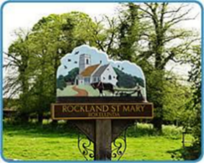
Rockland St Mary with Hellington Parish Council
AGENDA

The ANNUAL PARISH MEETING of Rockland St Mary with Hellington is being held:

Date: Wednesday 2nd April 2024
Time: Commences after a 2 min wait period after the Annual meeting of the Parish.
Place: Parish Room, Rockland St Mary

Charlotte Rust, Parish Clerk & RFO – parishclerk@rocklandstmarywithhellington-pc.gov.uk

- Welcome from the Chair.
- To retrospectively consider and approve safety barriers on the pond dipping platform.
- Finance:
  - To receive a Statement of Account as of 2nd April 2025.
  - To note any receipts and approve payments as per the April Payment Schedule.
- To confirm next meeting on Wednesday 7th May 2025 at 7.30pm at The Parish Room, Rockland St Mary.

