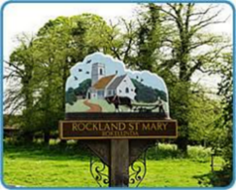
Rockland St Mary with Hellington Parish Council
AGENDA

The ANNUAL PARISH MEETING of Rockland St Mary with Hellington is being held:

Date: Wednesday 2nd April 2024
Time: 7.30pm, with refreshments being served from 7pm.
Place: Parish Room, Rockland St Mary

Charlotte Rust, Parish Clerk & RFO – parishclerk@rocklandstmarywithhellington-pc.gov.uk

- Welcome from the Chair.
- To receive and approve apologies for absence.
- To approve minutes of Annual Parish meeting of 3rd April 2024.
- Matters arising from the previous minutes (for information only).
- To receive Annual Reports:
  - District Councillor Vic Thomson.
  - County Councillor Kay Mason-Billig.
  - Chair of the Parish Council.
  - Poor’s Trust.
  - Parish Rooms (Roydon’s Trust).
  - Margaret Mack Room.
  - Hellington and Rockland St Mary Community Reserve (including report on the 200 club).
  - Rockland St Mary Primary School.
  - Parochial Church Council.
  - Bramrocks.
  - Gardening Club.
  - W.I.
  - Rockland Wildfowlers Association.
  - South Yare Wildlife Group.
  - Wheatfen.
  - Others.

