Rockland St Mary with Hellington Parish Council
Minutes of the Parish Council Meeting held on Wednesday 3rd December 2025 in The Parish Room, Rockland St Mary
(Subject to amendment until signed by the Chair at the next meeting)
Parish Councillors present Janet Rogers (Chair), Anthony Wright, Paul Francis,
County Councillor None
South Norfolk District Councillor Vic Thomson – left at 20:06pm
Members of the public (MOP) Three – Charlotte Rust; Parish Clerk and two parishioners

25.154 Welcome from the Chair.
Chair Rogers opened the meeting at 19:40pm and welcomed all those in attendance.
25.155 To receive and approve apologies for absence.
Councillors’ Norris, Harkin, Sayles and Forbes gave their apologies.
25.156 To receive any declarations of interest from Members & consider requests for dispensation.
None.
25.157 To approve minutes of Parish meeting of 5th November 2025.
Councillor Francis proposed for Councillor Rogers to sign the approved minutes, seconded by Councillor Wright.
25.158 Matters arising from November’s meeting.
- St Margaret’s ruins – the clerk had contacted Councillor Thomson regarding funding for a noticeboard, and he confirmed he had sent the request for £200 to South Norfolk District Council. The clerk will give an update at January’s meeting.
- Fencing at Community Orchard – 25.159.07.
- Crown Point Estate – the meeting with the clerk and chair has been rescheduled to 18th December.
- Defibrillator cabinet – at the time of the meeting donations totalled £225. The council would like to thank all those who have contributed so far. If you would like to donate, please email the clerk – parishclerk@rocklandstmarywithhellington-pc.gov.uk
- Replacement football nets are to be replaced in the Spring.
- Oak tree replacement relating to application 2023/1467 – in August 2023 the temporary Tree Preservation Order was removed on T1 which negates the requirement to replace it.
- Grit bins – the clerk is to ask the caretaker to have a look at the bin in Broadfields Way as it is solid.
25.159 Reports from:
25.159.01 County Councillor, Councillor Mason-Billig.
None at the time of the meeting.
25.159.02 District Councillor, Councillor Thomson.
Councillor Thomson gave an overview of his report; a full version will be available on the website once the clerk receives it:
- Poringland Oak public house has surplus sandbags just help yourself. Should you need to explain mention Councillor Vic Thomson’s name.
- Consultation on the Local Government Reorganisation.
25.159.03 Clerk Report.
The clerk gave her report:
- Informed parishioner who volunteered for the Community Speed Watch there were not enough volunteers.
- Submitted response to Norfolk County Council regarding footpath 3, expressing the council’s concerns over the safety on the position of the new steps. The clerk spoke to Claxton Parish Council about potentially contacting the owners of Claxton Manor requesting the permissive footpath be registered. Claxton Parish Council was happy for Rockland St Mary with Hellington Parish Council to contact them. Councillor Wright provided some background regarding this footpath and felt it would be best to not to contact Claxton Manor. The council decided not to pursue this. Councillor Thomson provided a contact in the Norfolk Trails team, and the clerk is to contact him to further raise the council’s safety concerns.
- Posters for Dog fouling received – the clerk has given them to Councillor Francis who will pass them to the caretaker.
- Paper recycling bank removal -the clerk has contacted both M. W. White and Norfolk County Council requesting the bank is removed as soon as possible. Both parties confirmed that the bank will be removed but no timescales can be given.
- Confirmed the council’s support of Operation Radium.
- Submitted the council’s response to PFR questionnaire.
- Updated the Action plan and is now on the website.
- Transport Made Simple Group meeting – Bramerton, Claxton, Rockland St Mary with Hellington and Surlingham Parish Councils are waiting for meeting dates, this will happen in January 2026.
- Scanning relevant historic documents so everything is electronic and preparing hard copies to be sent to the Archive Centre.
- All necessary correspondence forwarded.
25.159.04 Councillor Francis – Footpaths.
None.
25.159.05 Councillor Sayles and Steven Gildersleeve (SG), Caretaker – Blackhorse Dyke Car Park and defibrillators.
The clerk is to amend the proposed Memorandum of Understanding for the defibrillator to be installed on a parishioner’s property. Ready for approval at January’s meeting.
The clerk is to send a letter of thanks to the parishioner.
25.159.05.01 Complete Blackhorse Dyke Car Park project.
This item is deferred until January’s meeting.
25.159.06 Councillor Forbes – SAM2.
None.
25.159.07 Councillor Harkin – Biodiversity.
Discussions on fencing at the Community Orchard are deferred until January’s meeting.
25.159.08 Councillor Norris – Bird Hide.
The Project Manager has submitted the planning application for the Bird Hide to South Norfolk District Council.
25.160 Adjournment for Public Participation (15 minutes allowed for).
None.
25.161 To consider the Local government Reorganisation consultation questionnaire from Norfolk Association of Local Councils.
This item is deferred until January’s meeting.
Individual’s can respond to the questionnaire also, please click the link – Local Government Reorganisation.
25.162 Poor’s Trust:
25.162.01 To approve the Memorandum of Understanding for Staithe Car Park.
Councillor Wright proposed for Councillor Rogers to sign the Memorandum of Understanding, seconded by Councillor Francis.
25.162.02 To consider applications for Poor’s Trust Trustee vacancy.
Following a further resignation there were two vacancies.
The Council would like to thank Mr Bailey and Mr King for their service to the Poors Trust and wish them well for the future.
Councillor Francis proposed to appoint the two applicants, Mrs Jane Paterson and Mr James Pritchard as Trustees, seconded by Councillor Wright. The councillors voted, by show of hands, 3 FOR 0 AGAINST.
25.163 Grant requests:
25.163.01 To consider request for funding towards the Warm Room.
Councillor Wright proposed to award £150 of funding to the Warm Room to support the ongoing running costs, seconded by Councillor Francis.
25.163.02 To consider request for funding towards repairs to the Scout Hut of the 2nd Brundall Scout Group.
The clerk will contact 2nd Brundall Scout Group to explain the council will review this request in March 2026 to review available funds before awarding a grant.
25.164 Planning:
25.164.01 Decisions:
25.164.01.01 2025/3076 – Chantry House – Installation of roof lights and insulation; SOUTH NORFOLK DISTRICT COUNCIL APPROVAL WITH CONDITIONS.
Noted.
25.165 Finance:
25.165.01 To approve precept for 2026/2027 and leaflet.
Councillor Wright proposed the clerk submits paperwork requesting £19,000 precept from South Norfolk District Council and to include the council’s statutory duties total in the leaflet explain the reasons behind the percentage rise of the precept, seconded by Councillor Francis.
25.165.02 To receive a Bank Reconciliation and Statement of Account as of 3rd December 2025.
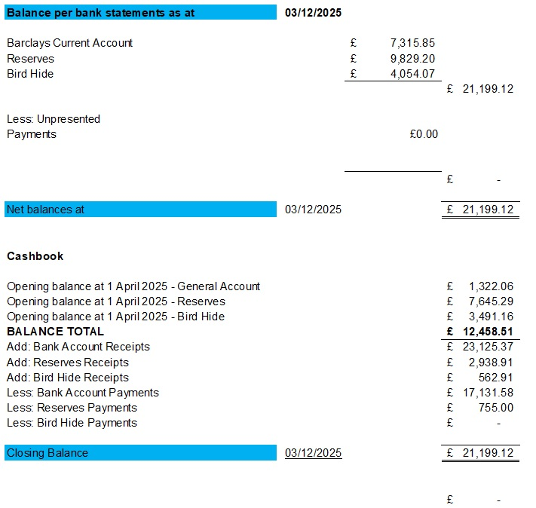

Councillor Francis proposed for Councillor Rogers and the Responsible Finance Officer to sign the Bank Reconciliation dated 3rd December 2025, seconded by Councillor Wright.
25.165.03 To note any receipts and approve payments as per December’s Payment Schedule.
FOR APPROVAL
 | DATE | EXPENDITURE | PAYMENT METHOD | TOTAL | VAT | P/R NO
Mr S Gildersleeve | 04.12.25 | November invoice | BACS | £356.50 | £0.00
Clerk | 04.12.25 | December expenses | BACS | £8.95 | £0.00
Clerk | 27.12.25 | December salary and WFH | BACS | £494.33 | £0.00
Heart2Heart | 03.12.25 | Defib cabinet | BACS | £415.00 | £0.00
HMRC | 04.12.25 | NI and PAYE up to 5th January | BACS | £7.47 | £0.00
TO NOTE INCOME
Parishioner | 24.11.25 | Defibrillator cabinet | BACS | £50.00 | £0.00 | R26
Green Pasture | 27.11.25 | Defibrillator cabinet | BACS | £50.00 | £0.00 | R27
The Studio at The Brickyard | 27.11.25 | Defibrillator cabinet | BACS | £50.00 | £0.00 | R28
Michala Jane School of Dance | 28.11.25 | Defibrillator cabinet | BACS | £75.00 | £0.00 | R29
Councillor Francis proposed to approve December’s Payment Schedule, seconded by Councillor Wright.
A parishioner made a donation of £100 for the defibrillator cabinet courtesy of her company Arena Illustration.
25.166 Correspondence:
25.166.01 Gritting of School Lane.
Following the unfortunate incident of a parishioner slipping and sustaining an injury, Steve Gildersleeve will be gritting School Lane as and when is required.
The clerk is to request Norfolk County Council to flush the drains along School Lane following heavy flooding.
25.166.02 Smartphone Free Childhood.
This is a campaign to delay getting children smartphones until at least 14, and social media 16. For more details please visit - http://www.smartphonefreechildhood.co.uk
25.167 To discuss items to add to the agenda for next Parish Council meeting.
None.
25.168 To confirm next meeting on Wednesday 7th January 2026 at 7.30pm at The Parish Room, Rockland St Mary.
Confirmed.
The councillors and clerk would like to wish all Rockland St Mary and Hellington’s parishioners a very Happy Christmas and New Year.

The meeting closed at 20:45pm

