Rockland St Mary with Hellington Parish Council
Minutes of the Parish Council Meeting held on Wednesday 3rd September 2025 in The Parish Room, Rockland St Mary
(Subject to amendment until signed by the Chair at the next meeting)
Parish Councillors present Chair Janet Rogers, Vice-Chair Joanne Norris, Anthony Wright, John Sayles, Paul Francis, Jayme Forbes
County Councillor None
South Norfolk District Councillor None
Members of the public (MOP) Twenty-one - Charlotte Rust; Parish Clerk, Steve Gildersleeve; Caretaker, Mr Dean King; Trustee to the Poors Trust and eighteen parishioners (seventeen with one parishioner joining the meeting at 20:05pm.

  - Welcome from the Chair.
Chair Rogers opened the meeting at 19:30pm and welcomed all those in attendance.
  - To receive and approve apologies for absence.
District Councillor Thomson sent his apologies.
  - To receive any declarations of interest from Members & consider requests for dispensation.
Councillor Norris declared an interest in item 8 (minute 25.110) and had provided a written request to the Proper Officer requesting dispensation to participate in discussion with no vote, in line with the council’s Standing Orders, s13f.
  - To approve minutes of Parish meeting of 2nd July 2025.
Councillor Francis proposed for Councillor rogers to sign the approved minutes, seconded by Councillor Sayles.
  - Matters arising from July’s meeting.
- Ben Goldsborough MP contacted Star Pubs requesting an update on the New Inn pub on behalf of the parish council and shared details of potential grants with the clerk that may be appropriate for the Bird Hide project.
- Solicitor to review the renewed Substation lease – the clerk is to forward the lease to Councillor Wright who will arrange for it to be reviewed free of charge to the council.
- Footpath near New Inn Hill – the clerk raised this with Norfolk County Council and councillors confirmed works had been completed.
- Defibrillator – please see minute 25.108.5.2.
- Risk Assessment for Community Orchard – Councillor Harkin has completed a risk assessment for the orchard and will forward this to the clerk.
- PKF Littlejohn LLP has completed the External Audit for 2024/2025, with no comments. The clerk will upload the required paperwork onto the website.
- Paper bank – M. W. White will be removing the bank in due course.
  - Reports from:
    - County Councillor, Councillor Mason-Billig.
Councillor Mason-Billig’s report was received after the meeting was held. A full copy will be available on the website:
- A146 Bus Service Improvements.
- Loddon and Chedgrave traffic improvements.
- Thurton crossing on A146.
- Norwich Castle Keep reopens following £27m redevelopment.
- Nationally recognised 'AI programme to be rolled out across Norfolk to prevent falls.
- Congratulations and support extended to further education students on results day.
- Repton Property delivers £1 million dividend.
- Long Stratton Bypass opens to traffic.
- Norfolk celebrates 2 million journeys by Beryl Bikes- Norfolk County Council, in partnership with Beryl and National Grid, is celebrating a major milestone for the county's innovative shared transport scheme.
    - District Councillor, Councillor Thomson.
None.
    - Clerk Report.
- Liaised with PKF Littlejohn LLP responding to questions during the External Audit.
- Contacted UK Power Networks requesting a copy of the Substation Lease, which was received the morning of the meeting.
- All necessary correspondence forwarded.
    - Councillor Francis – Footpaths.
Nothing to report.
    - Councillor Sayles and Steven Gildersleeve (SG), Caretaker – Blackhorse Dyke and Staithe Car
Parks, defibrillators.
Grass has been cut at Blackhorse Dyke, and the clothing bank has been removed.
Nothing to report on Staithe Car Park.
While awaiting a replacement battery, the caretaker temporarily installed the pub defibrillator’s battery into the unit near the Post Office. The clerk has since purchased a new battery.
      - Blackhorse Dyke project update.
The council has received back dated rent from UK Power Networks for the substation at Green Lane, totalling £1050. Councillor Rogers suggested the council could put these funds to reinstalling the fence once the paper recycling bank has been removed.
      - Defibrillator at New Inn Hill.
The defibrillator is currently without power, resulting in the deterioration of the pads due to the lack of temperature control within the cabinet. Relocating the defibrillator to a more suitable, powered location is being considered.
    - Councillor Forbes – SAM2.
Councillor Forbes is processing the data for June and July.
    - Councillor Harkin – Biodiversity.
Councillor Harkin provided an overview of the Community Orchard for all those in attendance.
      - To discuss pest control at the Community Orchard.
This item is deferred until the October meeting.
    - Councillor Norris – Bird Hide.
Councillor Norris confirmed the Bird Hide Working Group had appointed a Project Manager who has arranged for a Bat Survey and is waiting for the results. The group is hoping to be able to submit the planning application before the end of the year.

  - Adjournment for Public Participation (15 minutes allowed for).
The clerk asked all those in attendance if they objected to her recording the public participation section and item 8 (minute 25.110) of the meeting, to enable her to accurately minute parishioners’ comments. No objections were made.
Mr King, Trustee to the Poors Trust provided an overview of the charity:
The origins of the Rockland St. Mary Poor’s Trust date back to 1808. Following the Claxton and Rockland St Mary Enclosure Act, as compensation for the loss of Commoners Rights to gather firewood on the common land, commissioners determined that nine acres of land left over from the allocation of land to local farmers in the surrounding area of what is now the Staithe be given to a specially established charitable trust.
At this time, the sole purpose of the Trust was to manage this land in order that an annual fuel “allowance” (in the form of coal) be provided to parishioners in need whose ancestral right to collect fuel from “common” land had been taken away by the Act.
The original Trust land comprising largely of marshy meadow, reed beds and a small area suitable for allotment gardens, was given a new lease of life in the late 20th century when the area surrounding the Staithe was re-developed adding the existing car park, slipway, quay and grassed areas to the Trust’s assets.
In 1985 the Trust registered its charitable status, and the Charity Commission accepted its current constitution, and the Rockland St. Mary Fuel Allotment charity was formed.
What are the obligations of the Trust?
These are two-fold:
* Firstly to “maintain the property of the charity” in order for the charity to continue to be operational into the future
* To fulfil the charitable objectives stated in its constitution…“...relieving persons resident in the Parish who are in conditions of need, hardship and distress by making grants of money or providing or paying for items, services or facilities calculated to reduce (these)… ”
How is the raised money spent?
The largest annual outlay is keeping the areas around Staithe neat and tidy. (The grassed “amenity” areas cut and cleared of leaves, hedges and verges trimmed). The next largest cost is an annual insurance policy. Additionally, there is ongoing long-term maintenance to the now-aging infrastructure. (For example, in 2014 the Staithe jetty was replaced at a cost approaching £5,000; in 2016 car park repairs, allotment improvements and replacing rotting quay headings totalled nearly £3,000 and in 2017 the cost of refurbishing road side barriers opposite the New Inn and further quay heading replacement was in excess of £1,600). After asset maintenance costs have been met a proportion is set aside as a “reserve” and the remainder used for charitable distribution, now as grants of money, rather than coal.
Grants to individual parishioners are generally, though not always, made after a referral from local social services or other specific organisations such as Age UK. The charity also advertises locally for applications.
In the last financial year, grants in excess of £7600 were made to local parishioners in need of support, by the charity.
Points/questions raised by those in attendance:
- With the potential reinstallation of the Bird Hide, if the Staithe Car Park is closed where will the public park.
- Should the New Inn pub reopen where will the overflow parking be.
- Where will those leasing private moorings park.
- Prior to the Staithe Car Park being installed vehicles and trailers parked on the road, which affected access to parishioner property.
- Concerns for Emergency vehicle access with vehicles parked on the road
- A fatality on Lower Road, a number of years ago, as a result of parking on the road.
- Car park offers direct access to the allotments.
- Transparency of Trust funds would be beneficial.
- Overflow car park, on Trust land the far side of the footpath to the broad, has been closed and is now overgrown.
- Closing the car park during COVID 19 caused obstructions.
- Villages must change with the times, and it is not always about maximising income.
- Members of the Parish Council and the Poors Trust overlapped when the current lease was negotiated.
- What are the reserves of the Poors Trust being held for?
- Why did the Broads Authority not renew the moorings lease, Mr King confirmed the lease for moorings was not renewed as a rental price was not agreed between the two parties and the Broad Authority relocated its operations.
- Who maintained Staithe Car Park prior to the lease with the parish council?
- Is the Trust running at a deficit, Mr King confirmed the Trust was not.
- What is the Trust’s reserves balance, Mr King confirmed the balance is c.£36k held in an investment account, with limited access.
The clerk read Section 27, Application of Income of the charity’s governing documents stating: ‘Subject to payment of the expenses aforesaid the Trustees shall apply the income of the Charity in relieving either generally or individually persons resident in the Parish of Rockland St. Mary or the Parish of Hellington who are in conditions of need, hardship and distress by making grants of money or providing or paying for items, services or facilities calculated to reduce the need, hardship and distress of such persons.’
  - To discuss Staithe Car Park lease renewal.
The Proper Officer confirmed that she had received a written request for dispensation from Councillor Norris, in line with the council’s Standing Orders s13, d and f. Councillor Norris was granted dispensation to participate in discussion but not vote on this item, in accordance with the council’s Standing Orders s13,hii – person’s living in the council’s area.
Councillor Rogers provided an overview of the council’s offer to the Poor’s Trust following July’s meeting:
- An annual voluntary contribution towards the Staithe Car Park of £350p.a fixed for 5 years, with the understanding it remains an amenity for parishioners of Rockland St Mary and Hellington to use as well as for those who use it for the allotments and mooring.
- A Memorandum of Understanding rather than a lease.
- Contribution is reviewed every 5 years.
- All maintenance is managed by the Poor’s Trust.
- The council will continue to cover the cost of emptying the two dog bins at a cost of £200p.a.
Councillor Rogers provided the counteroffer received from the Poor’s Trust:
- An annual rental of £550 fixed for 5 years.
- As the public are the main users, the maintenance costs will be to the parish council.
- As suggested a Memorandum of Understanding is acceptable, appended to the previous lease.
- Provision of dog bins is a decision and cost for the parish council.
Councillor Rogers proposed the revised offer of:
- An annual voluntary contribution towards the Staithe Car Park of £550p.a fixed for 5 years, with the understanding it remains an amenity for parishioners of Rockland St Mary and Hellington and the wider public who use the amenities, allotments, staithe, moorings, slipway etc.
- A Memorandum of Understanding
- Contribution is reviewed every 5 years.
- All maintenance is managed by the Poor’s Trust.
- The council will continue to cover the cost of emptying the two dog bins at a cost of £278p.a.
Seconded by Councillor Francis. All councillors voiced their support of this proposal and took a vote, by show of hands:
FOR – 6
AGAINST – 0
ABSTAIN – 0
NO VOTE – 1
The clerk will email the Poor’s Trust Clerk with the revised offer.
  - To consider the lease for the Green Lane Substation with UK Power Network.
This item is deferred until October’s meeting.
  - To discuss the New Inn and Rockland Broad moorings.
Councillor Forbes proposed the council contact the Broads Authority on behalf of the Poor’s Trust requesting the mooring lease is reconsidered. seconded by Councillor Rogers. Councillor Rogers asked Mr Armitage to assist with drafting a letter. The clerk will action this.
  - Planning:
    - Applications:
      - 2025/2267 – The Old Hall - Details of conditions 4 & 5 of 2025/1091 - (4) detailed drawings of the proposed windows and doors & (5) detailed drawings and written specifications of the roof lights.
Noted.
    - Decisions:
      - 2025/1979 – Cherrydene Farm - Erection of agricultural storage building: SOUTH NORFOLK DISTRICT COUNCIL PRIOR APPROVAL NOT REQUIRED.
Noted.
      - 2025/2267 – The Old Hall - Details of conditions 4 & 5 of 2025/1091 - (4) detailed drawings of the proposed windows and doors & (5) detailed drawings and written
specifications of the roof lights: SOUTH NORFOLK DISTRICT COUNCIL APPROVAL WITH CONDITIONS.
Noted.
  - Finance:
    - To receive a Statement of Account as of 3rd September 2025.

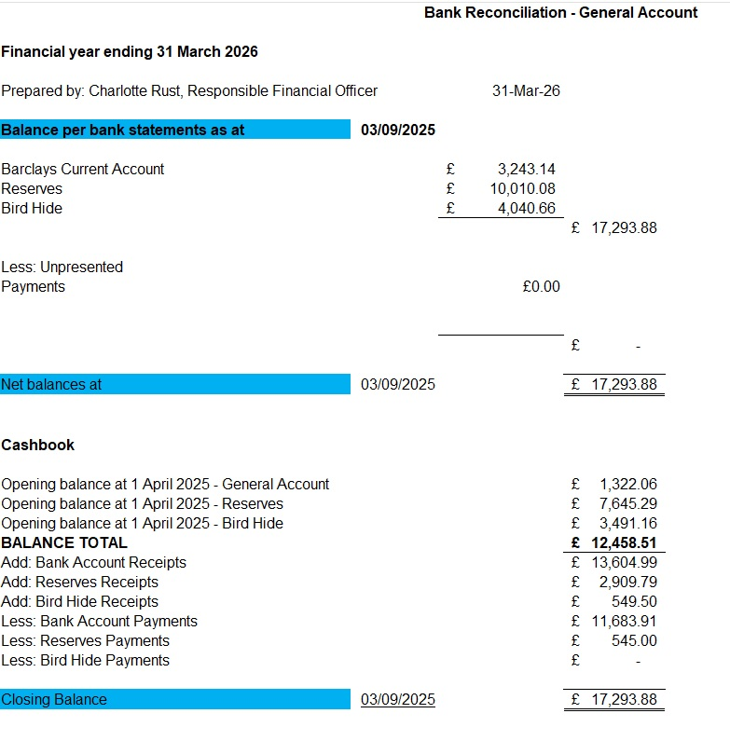

Councillor Norris proposed for the Chair and Responsible Finance Officer to sign the Bank Reconciliation dated 3rd September 2025, seconded by Councillor Sayles.
    - To approve the clerk’s national pay increase in line with the Local Government Services pay Agreement for 2025/2026.
Councillor Wright proposed to approve the clerk’s national pay increase, seconded by Councillor Francis.
    - To note any receipts and approve payments as per September’s Payment Schedule.

The clerk confirmed that the External Audit payment will be covered by reserves from a previous year. Councillor Norris proposed to approve the payment schedule, seconded by Councillor Harkin.
  - Correspondence:
    - Pond safety.
Please see minute 25.108.5.1.
    - Parking on the street.
A parishioner contacted the parish council with concerns over large agricultural vehicles causing damage to the verges and his property. The clerk is to contact Crown Point Estate raising the concerns.
    - Flag at Church.
The clerk responded to the parishioner confirming that the Parochial Church Council has a private donor who wishes to fund the flag replacement.
    - Paper recycling bank.
Please see minute 25.107.
    - Hearing Loop at Parish Room.
The clerk is researching into the legalities regarding hearing loops in a public space and will report back to the Parish Room.
  - To discuss items to add to the agenda for next Parish Council meeting.
Pest Control at the Community Orchard.
Substation Lease.
  - To confirm next meeting on Wednesday 1st October 2025 at 7.30pm at The Parish Room, Rockland St Mary.
Confirmed. Councillors Rogers and Norris gave their apologies in advance. Councillor Harkin offered to chair the meeting.

The public section of the meeting closed at 20:48pm

  - Resolution to exclude members of the public and press under the Public Bodies (Admission to Meetings) Act 1960.
    - To discuss items in preparation for the clerk’s appraisal and pay scale increase from SCP17 to SCP18 following the completion of her CiLCA qualification.
The clerk’s appraisal will be held on Tuesday 15th September with the details minuted at October’s meeting.

The meeting closed at 21:12pm.

