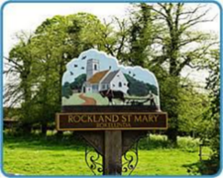
Rockland St Mary with Hellington Parish Council
AGENDA

Date: Wednesday 22 October 2025
Time: 7.30pm
Place: Parish Room, Rockland St Mary
AGENDA
1. Welcome.

2. Approval of the Minutes of 26 February 2025.
3. Matters arising:
3.1 Consultation to consider disbanding the Broads Management Committee.

4. Reports and updates from members:
4.1 RWA.
4.2 Poor's Trust.
4.3 RSPB.
4.4 Wheatfen.
4.5 Broads Authority.
4.6 South Yare Wildlife Group.

5. Bird Hide – Progress report.

6. Impact of the loss of the Broads Authority Moorings to the village.

7. Change of Management of Staithe Car Park.

8. Consider permission to install a memorial bench for a parishioner.

9. AOB and any matters for inclusion at the next meeting.

10. Confirm next meeting date.

